Student’s name | …………………………………………………….…… | Grade | 4
Subject | Computer | Week No. | 12
Lesson Title | Operators | Unit
Worksheet No. ( 12 )

Question A: Write the correct name of each part.

Turn | Repeat | Event | Switch

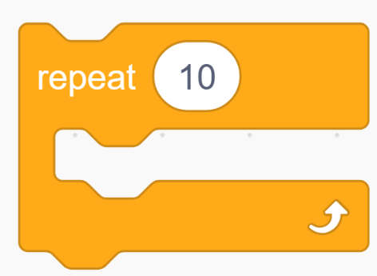


Good Luck

